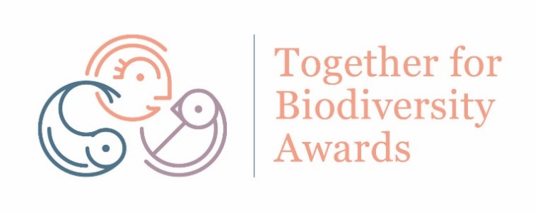
Application Form & Conditions

To apply please fill in each section of this form and email it to awards@iwt.ie
Closing date for application 10th December
1. NAME (Name of group/school/individual):

2. CONTACT PERSON DETAILS (please write details of a contact person for your application)
Name:
Phone:
Email:

3. PROJECT TITLE:
4. CATEGORY (Please indicate below which category you are applying for or email awards@iwt.ie for advice.)
People Together for Biodiversity Award (open to community groups)
Category A - (Small community group project, run on less than €3,000 budget)
Category B - (Large community group project, run on more than €3,000 budget)
Local Biodiversity Champion Award (open to any individual)
Category C - (Project run by an Individual - leading change for biodiversity at local level)
Learning Together for Biodiversity Award (open to schools)
Category D - (Project run by a School - leading on biodiversity through education)
Write category letter here:

5. DESCRIPTION OF THE PROJECT
What did you do and how did you do it? Include information on the species and habitats that you chose to focus on (300 words):
What positive biodiversity impact did your project have? (300 words):
What community impact did your project have (if any)? (300 words):
What location did your project take place in?
6. PHOTOS OF THE PROJECT
Please attach to your application up to 4 photos illustrating the project you carried out. Attach these as separate photo files in your email. No more than 2MB size photos please.
Closing date for submissions is 10th December
Submit you application form and photos via email to awards@iwt.ie

Terms and Conditions

- Projects will be reviewed solely based on the information submitted
- Applications will be ranked by points for biodiversity impact and community engagement
- The six highest scoring applications per category will progress to a public voting round in December
- The top three public voted projects in each category will progress to the finalist stage.
- By entering, applicants agree that should their project progress to finalist stage, they will present a poster on the project at the National Biodiversity Conference on 20th and 21st February in Dublin.
- A winner for each category will be picked by a panel chosen by the award organisers
- The category winners will be announced at the National Biodiversity Conference
- Winning projects may be visited by IWT to document the work carried out
- Projects run by community groups, schools, farmers and individuals are eligible to apply in the relevant category
- No businesses, national organisations or staffed Environmental NGOs are eligible to apply
- Only one application per group or individual

This awards scheme is delivered by the Irish Wildlife Trust as part of the National Biodiversity Conference and are kindly sponsored by Dublin Port Company

  